ITE16 - Multimedia Systems
Laboratory Exercise #1
Getting to Know the Work Area

Name: Date:

Code/Schedule: Terminal #:

Estimated Completion Time: 2 meetings

Objectives:
In this lesson, you’ll learn how to do the following:
- Open Adobe Photoshop files.
- Select and use some of the tools in the Tools panel.
- Set options for a selected tool using the options bar.
- Use various methods to zoom in on and out from an image.
- Select, rearrange, and use panels.
- Choose commands in panel and context menus.
- Open and use a panel docked in the panel well.
- Undo actions to correct mistakes or to make different choices.
- Customize the workspace.
- Find topics in Photoshop Help.

Discussion:

Download the instructions from our course portal. Below are the sample outputs for this exercise.

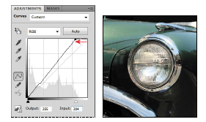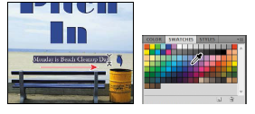

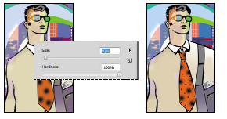
ITE16 - Multimedia Systems
Laboratory Exercise #2
Basic Photo Corrections

Name: Date:

Code/Schedule: Terminal #:

Estimated Completion Time: 2 meetings

Objectives:
In this lesson, you’ll learn how to do the following:
- Understand image resolution and size.
- Open and edit an image in Camera Raw.
- Adjust the tonal range of an image.
- Straighten and crop an image.
- Paint over a color with the Color Replacement tool.
- Adjust the saturation of isolated areas of an image using the Sponge tool.
- Use the Clone Stamp tool to eliminate an unwanted part of
- an image.
- Use the Spot Healing Brush tool to repair part of an image.
- Use content-aware fill to remove blemishes.
- Apply the Unsharp Mask filter to finish retouching photos.
- Save an image file for use in a page layout application.

Discussion:
Download the instructions from our course portal. Below are the sample output. for this exercise.
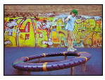

ITE16 - Multimedia Systems
Laboratory Exercise #3
Working With Selections

Name: Date:

Code/Schedule: Terminal #:

Estimated Completion Time: 2 meetings

Objectives:
In this lesson, you’ll learn how to do the following:
- Make specific areas of an image active using selection tools.
- Reposition a selection marquee.
- Move and duplicate the contents of a selection.
- Use keyboard-mouse combinations that save time and hand motions.
- Deselect a selection.
- Constrain the movement of a selected area.
- Adjust the position of a selected area using the arrow keys.
- Add to and subtract from a selection.
- Rotate a selection.
- Use multiple selection tools to make a complex selection.
- Erase pixels within a selection.Make specific areas of an image active using selection tools.

Discussion:

This lesson will take about an hour to complete. Copy the Lesson03 folder onto your hard drive if you haven’t already done so. As you work on this lesson, you’ll preserve the start files. If you need to restore the start files, copy them from the server. Expected output is shown below.

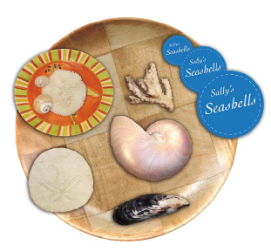

ITE16 - Multimedia Systems
Laboratory Exercise #4
Layers
Name: Date:

Code/Schedule: Terminal #:

Estimated Completion Time: 2 meetings

Objectives:
In this lesson, you’ll learn how to do the following:
- Organize artwork on layers.
- Create, view, hide, and select layers.
- Rearrange layers to change the stacking order of artwork.
- Apply blending modes to layers.
- Resize and rotate layers.
- Apply a gradient to a layer.
- Apply a filter to a layer.
- Add text and layer effects to a layer.
- Save a copy of the file with the layers flattened.

Discussion:

This lesson will take about an hour to complete. Copy the Lesson04 folder onto your hard drive if you haven’t already done so. As you work on this lesson, you’ll preserve the start files. If you need to restore the start files, copy them from the server. Expected output is shown below.

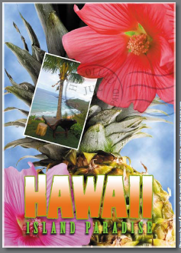

ITE16 - Multimedia Systems
Laboratory Exercise #5
Correcting and Enhancing Digital Photographs

Name: Date:

Code/Schedule: Terminal #:

Estimated Completion Time: 2 meetings

Objectives:
In this lesson, you’ll learn how to do the following:
- Process a proprietary camera raw image and save your adjustments.
- Merge images of different exposures to create a high dynamic range (HDR) image.
- Make typical corrections to a digital photograph, including removing red eye and noise and bringing out shadow and highlights detail.
- Apply optical lens correction to an image.
- Align and blend two images to extend the depth of field.
- Adopt best practices for organizing, managing, and saving your images.

Discussion:

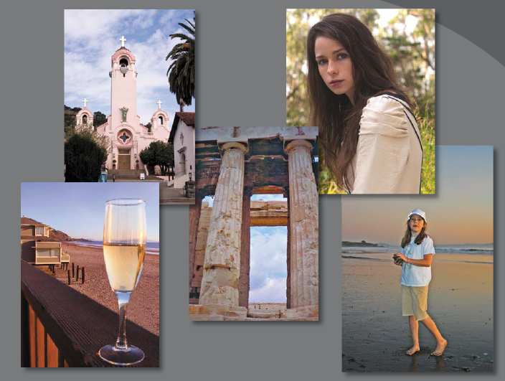
This lesson will take about 1 1/2 hour to complete. Copy the Lesson05 folder onto your hard drive if you haven’t already done so. As you work on this lesson, you’ll preserve the start files. If you need to restore the start files, copy them from the server. Expected output is shown below.
ITE16 - Multimedia Systems
Laboratory Exercise #6
Masks and Channels

Name: Date:

Code/Schedule: Terminal #:

Estimated Completion Time: 2 meetings

Objectives:
In this lesson, you’ll learn how to do the following:
- Create a mask to remove a subject from a background.
- Refine a mask to include complex edges.
- Create a quick mask to make changes to a selected area.
- Edit a mask using the Masks panel.
- Manipulate an image using Puppet Warp.
- Save a selection as an alpha channel.
- View a mask using the Channels panel.
- Load a channel as a selection.

Discussion:

This lesson will take about 1 hour to complete. Copy the Lesson06 folder onto your hard drive if you haven’t already done so. As you work on this lesson, you’ll preserve the start files. If you need to restore the start files, copy them from the server. Expected output is shown below.
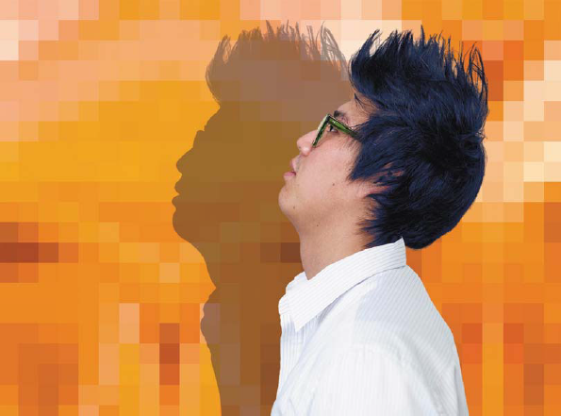

ITE16 - Multimedia Systems
Laboratory Exercise #7
Typographic Design

Name: Date:

Code/Schedule: Terminal #:

Estimated Completion Time: 2 meetings

Objectives:
In this lesson, you’ll learn how to do the following:
- Use guides to position text in a composition.
- Make a clipping mask from type.
- Merge type with other layers.
- Format text.
- Distribute text along a path.
- Control type and positioning using advanced features. panel.
- Load a channel as a selection.

Discussion:

This lesson will take about 1 hour and 15 minutes to complete. Copy the Lesson07 folder onto your hard drive if you haven’t already done so. As you work on this lesson, you’ll preserve the start files. If you need to restore the start files, copy them from the server. Expected output is shown below.


ITE16 - Multimedia Systems
Laboratory Exercise #8
Vector Drawing Techniques

Name: Date:

Code/Schedule: Terminal #:

Estimated Completion Time: 2 meetings

Objectives:
In this lesson, you’ll learn how to do the following:
- Differentiate between bitmap and vector graphics.
- Draw straight and curved paths using the Pen tool.
- Convert a path to a selection, and convert a selection to a path.
- Save paths.
- Draw and edit shape layers.
- Draw custom shapes.
- Import and edit a Smart Object from Adobe Illustrator.

Discussion:

This lesson will take about 1 hour and 15 minutes to complete. Copy the Lesson08 folder onto your hard drive if you haven’t already done so. As you work on this lesson, you’ll preserve the start files. If you need to restore the start files, copy them from the server. Expected output is shown below.

